**Introduction:**

Same these three images

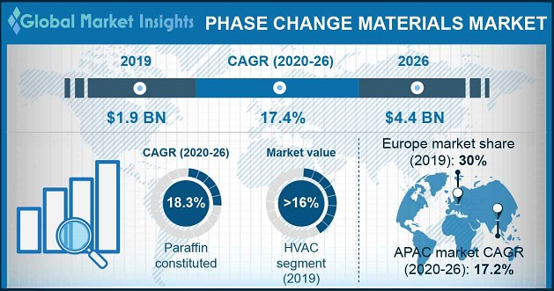

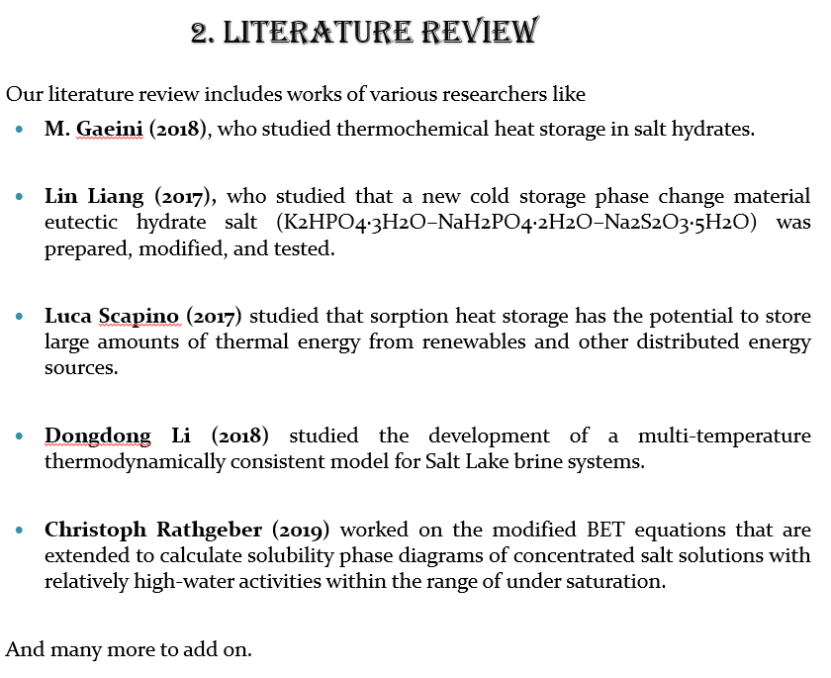

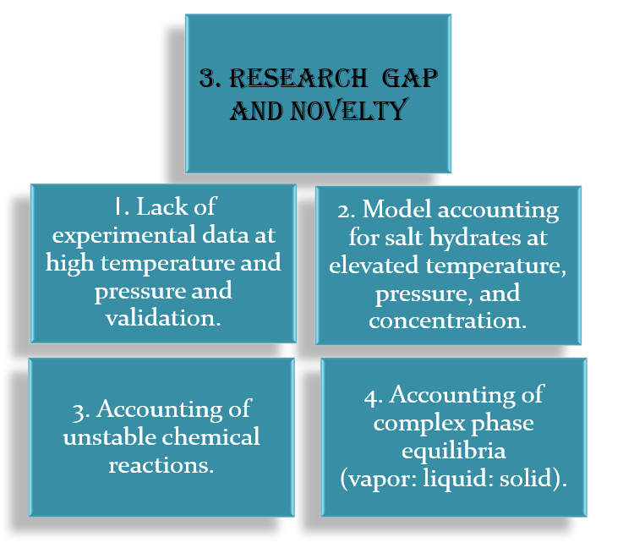

**Methodology:**

In our work, total Gibbs free energy of the system is given by summation of long range (Lr) and short-range interactions (Sr), i.e.,

Short Range

Long Range

In which,

nw, ns = no. of moles of water, salt respectively

vs, vw = partial molar volume (m3/mole) of salt, solvent respectively

b = the closest approach parameter

Total no. of ions per salt

Ax = Debye Huckel type constant

Ix = Ionic Strength

= salt-water interaction parameter

Øs, Øw = Volume fraction of salt and water respectively

In this analysis, we explore the empirical form of as follows:

is temperature dependent coefficient and as expressed as:

where, and are constants.

Derivative of Equation (8) w. r. t. moles of water and salt gives us chemical potential of water and salt hydrate respectively.

The osmotic coefficient (φ) of an aqueous electrolyte is related to the chemical potential of water, (µw), as follow:

The critical point is determined by the following condition:

**Results and Discussion:**

Table – 1: The least square estimates of constants , and , obtained from osmotic coefficient data for n = 3

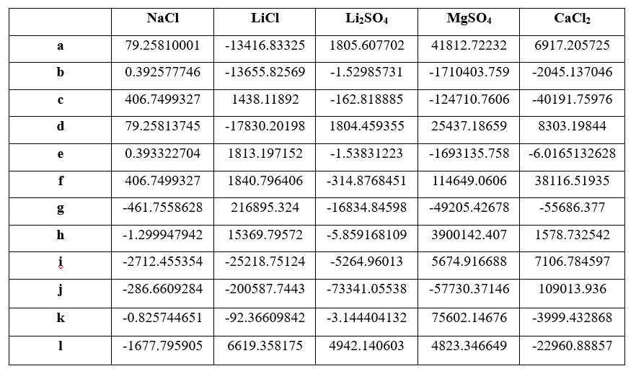

Table – 2: The least square estimates of constants , , and obtained from osmotic coefficient data for n = 4

Table – 3: The comparison table for the deviation percentage for osmotic coefficient from our work with the reference values.

Once you are done with these tables, start making slides for graphs. During our first ppt u made all parity plot in same slide right like that u make.

N=2, all 5 parity plot in one slide

N=3 and N=4 similarly.

Like this u do, but then in figure number when u r typing include the reference numbers as well. So, in ppt, the reference which we will be adding is only of those 20 or 25 references that we used for results and conclusion part alone at the starting. I added those below u can take from here itself if u want.

Similarly for Temperature vs Volume fraction graphs – 2 images in one slide u add.

At the end add this critical points table.

Table – 4: The comparison table for the critical point values from our work with reference values

Mathematica Code:

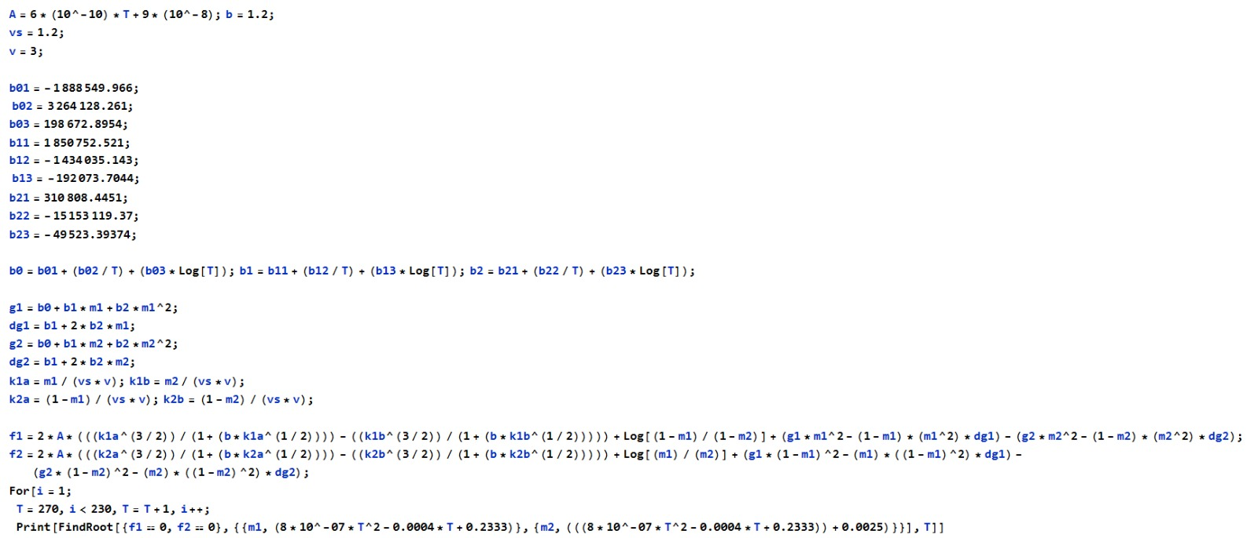

**Summary and Conclusion:**

Same as third review ppt

**REFERENCES FOR CONCLUSION AND RESULTS**

1. Pielichowska, K.; Pielichowski, K. Phase change nanomaterials for thermal energy storage. In *Nanotechnology for Energy Sustainability*; Wiley: Hoboken, NJ, USA, 2017; pp. 459–484.
2. H. Lahmidi, S. Mauran, V. Goetz, Definition, test and simulation of a thermochemi cal storage process adapted to solar thermal systems, Sol. Energy 80 (7) (2006) 883–893
3. Li, D., Zeng, D., Yin, X., Han, H., Guo, L., & Yao, Y. (2016). Phase diagrams and thermochemical modeling of salt lake brine systems. II. NaCl+ H2O, KCl+ H2O, MgCl2+ H2O and CaCl2+ H2O systems. *Calphad*, *53*, 78-89.
4. Guendouzi, M. E., Mounir, A., & Dinane, A. (2003). Water activity, osmotic and activity coefficients of aqueous solutions of Li2SO4, Na2SO4, K2SO4,(NH4) 2SO4, MgSO4, MnSO4, NiSO4, CuSO4, and ZnSO4 at T= 298.15 K. *The Journal of Chemical Thermodynamics*, *35*(2), 209-220.
5. Pillay, V., Gärtner, R. S., Himawan, C., Seckler, M. M., Lewis, A. E., & Witkamp, G. J. (2005). MgSO4+ H2O System at Eutectic Conditions and Thermodynamic Solubility Products of MgSO4⊙ 12H2O (s) and MgSO4⊙ 7H2O (s). *Journal of Chemical & Engineering Data*, *50*(2), 551-555.
6. Li, D., Zeng, D., Yin, X., & Gao, D. (2018). Phase diagrams and thermochemical modeling of salt lake brine systems. III. Li2SO4+ H2O, Na2SO4+ H2O, K2SO4+ H2O, MgSO4+ H2O and CaSO4+ H2O systems. *Calphad*, *60*, 163-176.
7. Archer, D. G., & Rard, J. A. (1998). Isopiestic Investigation of the Osmotic and Activity Coefficients of Aqueous MgSO4 and the Solubility of MgSO4⊙ 7H2O (cr) at 298.15 K: Thermodynamic Properties of the MgSO4+ H2O System to 440 K. *Journal of Chemical & Engineering Data*, *43*(5), 791-806.
8. Yang, H., Zeng, D., Wang, Q., Chen, Y., & Voigt, W. (2016). Isopiestic measurements of water activity for the Li2SO4–MgSO4–H2O system at 323.15 and 373.15 K. *Journal of Chemical & Engineering Data*, *61*(9), 3157-3162.
9. Guendouzi, M. E., Mounir, A., & Dinane, A. (2003). Water activity, osmotic and activity coefficients of aqueous solutions of Li2SO4, Na2SO4, K2SO4,(NH4) 2SO4, MgSO4, MnSO4, NiSO4, CuSO4, and ZnSO4 at T= 298.15 K. *The Journal of Chemical Thermodynamics*, *35*(2), 209-220.
10. Monnin, C., Dubois, M., Papaiconomou, N., & Simonin, J. P. (2002). Thermodynamics of the LiCl+ H2O system. *Journal of Chemical & Engineering Data*, *47*(6), 1331-1336.
11. Pátek, J., & Klomfar, J. (2006). Solid–liquid phase equilibrium in the systems of LiBr–H2O and LiCl–H2O. *Fluid Phase Equilibria*, *250*(1-2), 138-149.
12. Li, D., Zeng, D., Han, H., Guo, L., Yin, X., & Yao, Y. (2015). Phase diagrams and thermochemical modeling of salt lake brine systems. I. LiCl+ H2O system. *Calphad*, *51*, 1-12.
13. Rard, J. A., Clegg, S. L., & Palmer, D. A. (2007). Isopiestic determination of the osmotic and activity coefficients of Li 2 SO 4 (aq) at T= 298.15 and 323.15 K, and representation with an extended ion-interaction (Pitzer) model. *Journal of solution chemistry*, *36*, 1347-1371.
14. Hamer, W. J., & Wu, Y. C. (1972). Osmotic coefficients and mean activity coefficients of uni‐univalent electrolytes in water at 25° C. *Journal of Physical and Chemical Reference Data*, *1*(4), 1047-1100.
15. Rudakov, A. M., Sergievskii, V. V., & Nagovitsyna, O. A. (2017). Dependences of the osmotic coefficients of aqueous calcium chloride solutions on concentration at different temperatures. *Russian Journal of Physical Chemistry A*, *91*, 2361-2365.
16. Czerwienski, G. J. (1986). Osmotic and mean activity coefficients of CaCl2, NaI, LiBr and LiCl in ethanol at 50 degrees C.
17. Partanen, J. I. (2012). Traceable mean activity coefficients and osmotic coefficients in aqueous calcium chloride solutions at 25 C up to a molality of 3.0 mol· kg–1. *Journal of Chemical & Engineering Data*, *57*(11), 3247-3257.
18. DUCKETT, L., HOLLIFIELD, J., & PATTERSON, C. (1986). Osmotic coefficients of aqueous CaCl2 solutions from 3 to 12 m at 50 oC. *Journal of chemical and engineering data*, *31*(2), 213-214.
19. Ananthaswamy, J., & Atkinson, G. (1985). Thermodynamics of concentrated electrolyte mixtures. 5. A review of the thermodynamic properties of aqueous calcium chloride in the temperature range 273.15-373.15 K. *Journal of Chemical and Engineering Data*, *30*(1), 120-128.
20. Gruszkiewicz, M. S., & Simonson, J. M. (2005). Vapor pressures and isopiestic molalities of concentrated CaCl2 (aq), CaBr2 (aq), and NaCl (aq) to T= 523 K. *The Journal of Chemical Thermodynamics*, *37*(9), 906-930.
21. Goldberg, R. N., & Nuttall, R. L. (1978). Evaluated activity and osmotic coefficients for aqueous solutions: The alkaline earth metal halides. *Journal of Physical and Chemical Reference Data*, *7*(1), 263-310.
22. Staples, B. R., & Nuttall, R. L. (1977). The activity and osmotic coefficients of aqueous calcium chloride at 298.15 K. *Journal of Physical and Chemical Reference Data*, *6*(2), 385-408.
23. Pitzer, K. S., & Shi, Y. (1993). Thermodynamics of calcium chloride in highly concentrated aqueous solution and in hydrated crystals. *Journal of solution chemistry*, *22*, 99-105.